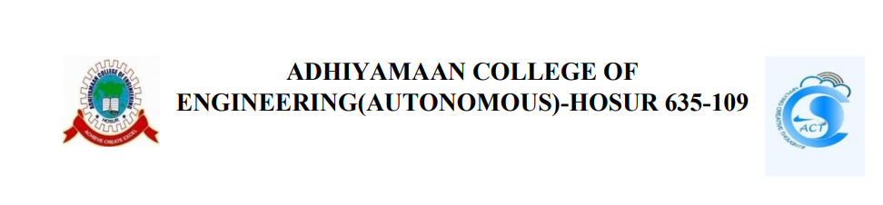

**SECURE COMPLAINT MANAGEMENT SYSTEM**

**A PROJECT REPORT**

**Submitted by**

1. MANASADEVI J (6176AC22UCS089)
2. PAVITHRA A (6176AC22UCS112)

In partial fulfilment for the award of the degree of BACHELOR OF ENGINEERING In COMPUTER SCIENCE ENGINEERING

### ACKNOWLEDGEMENT

We convey our sincere gratitude to Adhiyamaan College of Engineering (Autonomous) for providing us the opportunity to work on this project. We extend our heartfelt thanks to Mrs. Kasthuri (Asst. Prof) for her valuable guidance and support throughout this project. We also express our thanks to the Principal and all faculty members of the department for their continuous motivation and advice.

### DECLARATION

We hereby declare that the project work entitled "secure complaint management system" submitted by us for the partial fulfilment of the requirement for the award of Bachelor of Computer Science Engineering, is an authentic work completed by our team. The report being submitted has not been submitted earlier for the award of any degree to any institute or university.

**CONTENT**

**1. Introduction to the Project**

* Purpose of the Project
* Objectives of the project

**2. Project Features**

* Technologies used
* Project Workflow

**3. System Security**

* Form validation
* Security Measures

**4. Output Screens**

**5. Conclusion**

* Future Improvement

**INTRODUCTION TO THE PROJECT**

The Complaint Box System is a web-based platform designed to allow users (students, employees, or customers) to submit complaints and track their status. The system provides a secure and user-friendly interface for posting complaints, with features that enable tracking and status updates, ensuring complaints are handled transparently and efficiently. The project focuses on privacy, user authentication, and security, ensuring that complaint data is protected from unauthorized access.

**PURPOSE OF THE PROJECT**

The purpose of the **Complaint Box System** is to provide a streamlined, digital platform for submitting, tracking, and managing complaints securely. It enhances transparency by allowing users to track complaint statuses using unique IDs and passwords, while ensuring efficient complaint management for administrators. The system also promotes security through input validation and protection against malicious activities, fostering accountability and trust between users and the organization.

### 2. Objectives

### To create a digital platform for users to submit complaints.

### To provide a system that allows users to track the status of their complaints using a unique complaint ID and password.

### To ensure data security through form validation and protection against attacks such as SQL injection and cross-site scripting (XSS).

### To enhance the user experience by adding a notification system that informs users of status changes via email or in-app alerts.

### To allow admins to manage and update the complaints, with restricted access to the admin panel through secure authentication.

### 3. Project Features

### Complaint Submission:

### Users can submit complaints by filling out a form.

### Complaints are tagged with a unique ID and associated with the user's password for secure tracking.

### Complaint Status Tracking:

### Users can check the status of their complaints using the unique complaint ID and password.

### Complaint statuses include "Submitted," "Under Review," and "Resolved."

### User Authentication (Moderate Version):

### Admin login system using Passport.js or JWT.

### Admins can view all complaints and update their status.

### Security Measures:

### Form Validation: Input length limits, ensuring proper data formats.

### SQL Injection Prevention: Measures taken to prevent harmful SQL queries from being executed.

### Cross-Site Scripting (XSS) Protection: Implemented to prevent malicious scripts from being injected into the web application.

### Notification System (Planned):

### Email or in-app notifications will be sent to users when the status of their complaint changes.

### The notification system will be triggered by backend logic when an admin updates the complaint status.

### 4. Technologies Used

### Frontend: HTML, CSS, JavaScript

### Backend: Node.js with Express framework

### Database: MySQL (for complaint storage and admin data)

### Security: Form validation, input sanitization

### Authentication: Passport.js/JWT for admin login

### Notification System: NodeMailer (for email notifications)

### Version Control: Git

### 5. Project Workflow

### Phase 1:

### Basic version implemented with complaint submission and status tracking features.

### Form validation and security measures were put in place to ensure safe data handling.

### Phase 2:

### Moderate version implementation involving user authentication (admin login) and enhanced security features (SQL Injection and XSS protection).

### Phase 3 (Planned):

### Develop the notification system (email or in-app).

### Integrate a notification trigger whenever a complaint status is updated by the admin.

### 6. Challenges and Solutions

### Complaint ID Security:

### Challenge: Ensuring that users can securely track their complaints.

### Solution: Added password input during complaint submission, which is required along with the complaint ID to check status.

### Input Validation:

### Challenge: Preventing malicious input in complaint forms.

### Solution: Implemented input sanitization and form validation for length and special characters.

### Notification System:

### Challenge: Building a system that reliably informs users of complaint updates.

### Solution: Planned integration of NodeMailer to send emails automatically when complaint statuses change.

### 8. Screenshots

### OUTPUT SCREENS

The application includes various screens for different functionalities:

1. **Home Page:**The landing page where users are introduced to the system. It provides a basic overview of how to submit complaints and access their status.

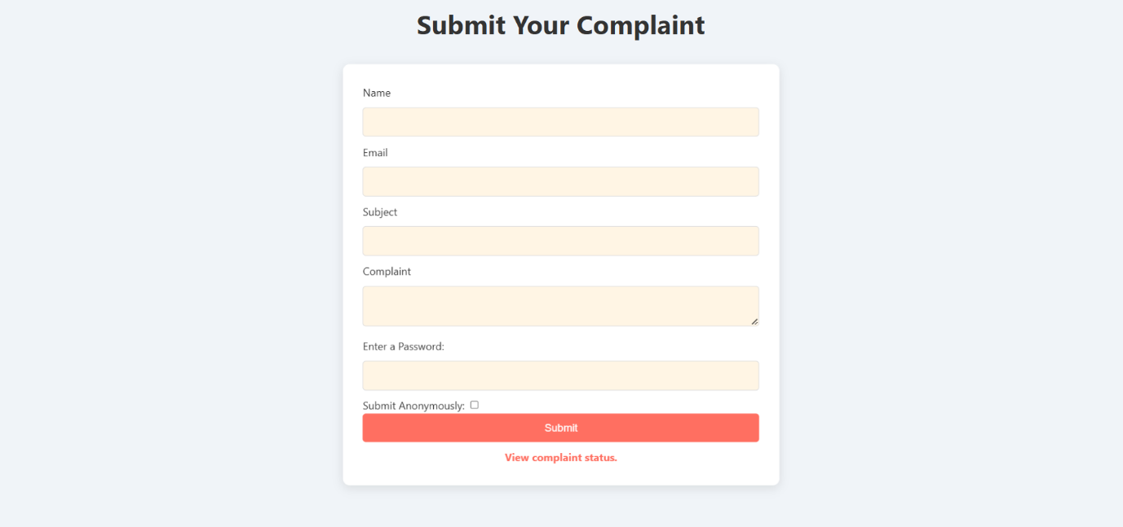

**2.Complaint Submission Page**:This page contains a form where users can submit their complaints, including fields for details and a password for secure tracking..

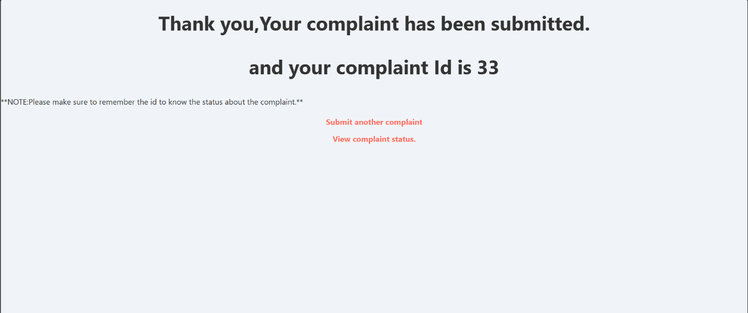

**3.Complaint Status Tracking Page**:Allows users to enter their unique complaint ID and password to check the current status of their complaints.

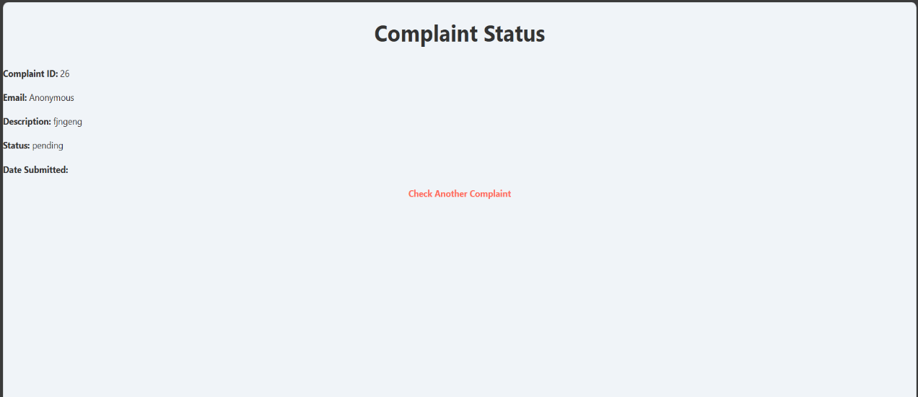

**4.Complaint Details Page :**  
A detailed view where admins can see the full information for individual complaints, update status, and add remarks.

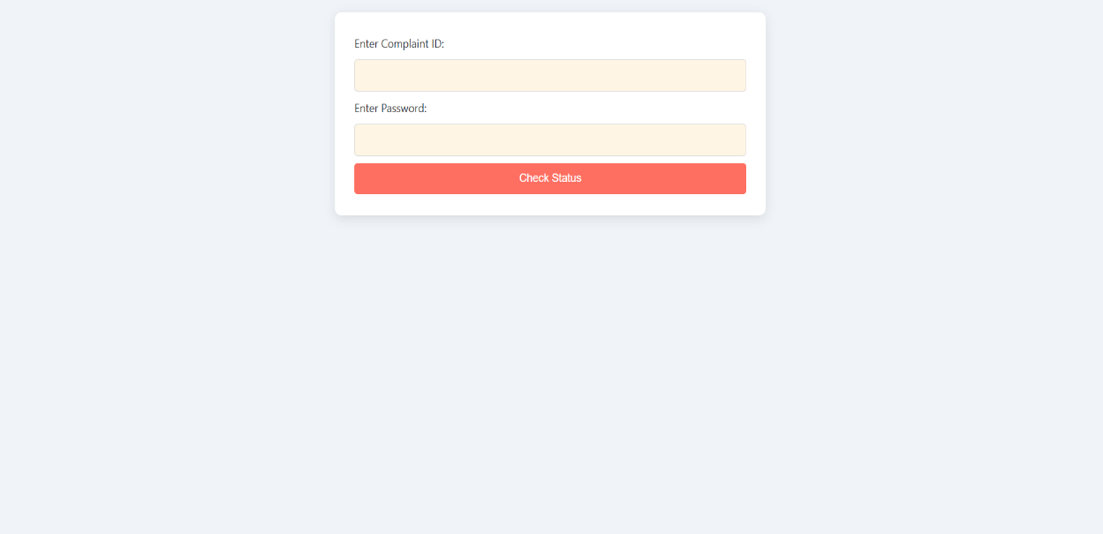

**5.Admin Dashboard :**  
The backend interface where administrators can view all submitted complaints, update their statuses, and manage the system.

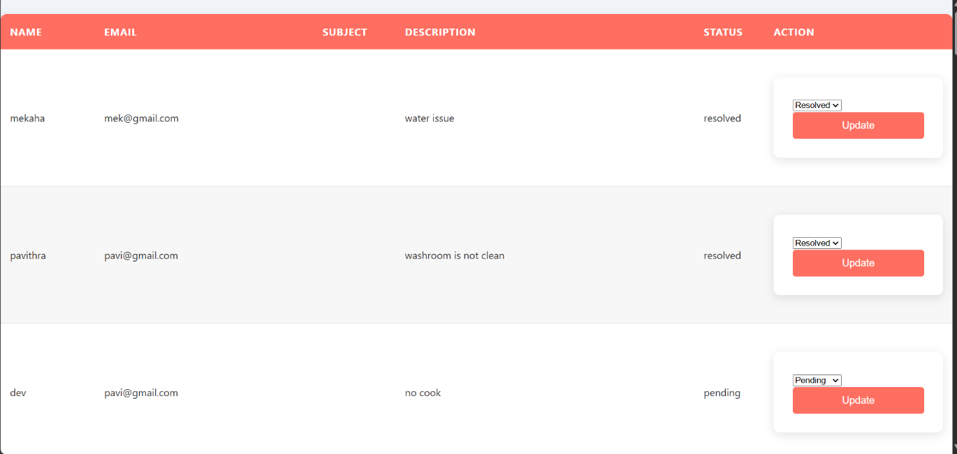

### 9. Conclusion and Future Work:

### The Complaint Box System provides a simple and effective solution for handling and tracking complaints in an organization. The core features include submission, status tracking, and admin management with authentication. Future improvements include the addition of a notification system to enhance user experience and improve communication between admins and users. Further security enhancements can also be explored, such as two-factor authentication for admins and stronger encryption for stored data.

### Next Steps:

### Complete the notification system.

### Further refine the user authentication mechanism and ensure scalability.